Case 6-AFR-Congo-Mask-Songye Kifwebe-**1910**

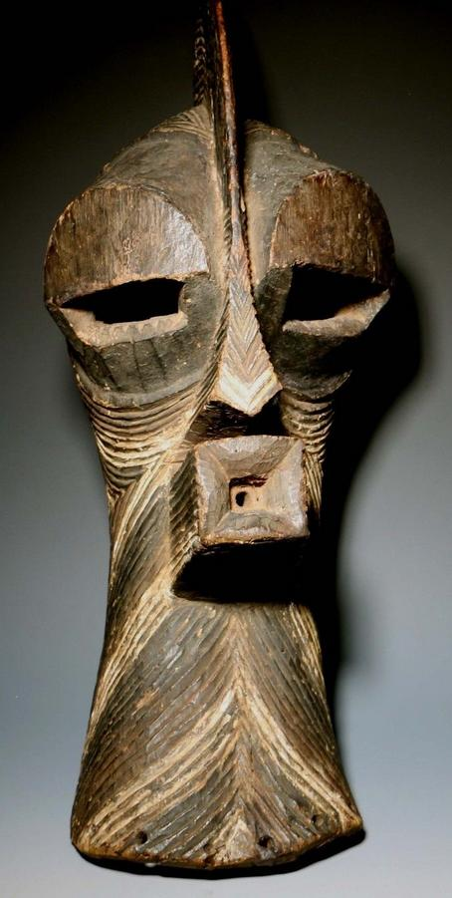

**Country: Congo (D.R.C.)**

**People: Songye**

**Period: Early 20th Century**

**Material: Wood/Pigmentation**

**Dimensions: L x W x D (cm)**

**Weight: lb 7 oz (kg gm)**

**Description:**

**A large Songye Kifwebe mask.  The mask is a classic Kifwebe stylized mask with a sagittal crest,** **protruding eyes, nose and quadrangular mouth.  Incised lines throughout with black and white pigmentation.  Raffia holes at sides.**

Price:

US $3,750.00